

A lingual arch is used to hold space and maintain arch length in either the upper or lower jaw. It is most commonly used when there is early loss of baby teeth or if there’s a crowding problem in the mixed dentition. The lingual holding arch can help relieve crowding and reduce the likely need for extraction of permanent teeth in the future.

**Oral Hygiene**

Good oral hygiene is important as there are more areas for food and plaque to become trapped. Correct brushing is very important to clean the difficult to reach areas around the molars and roof of your mouth. Ideally you should be brushing your teeth 2-3 times per day.

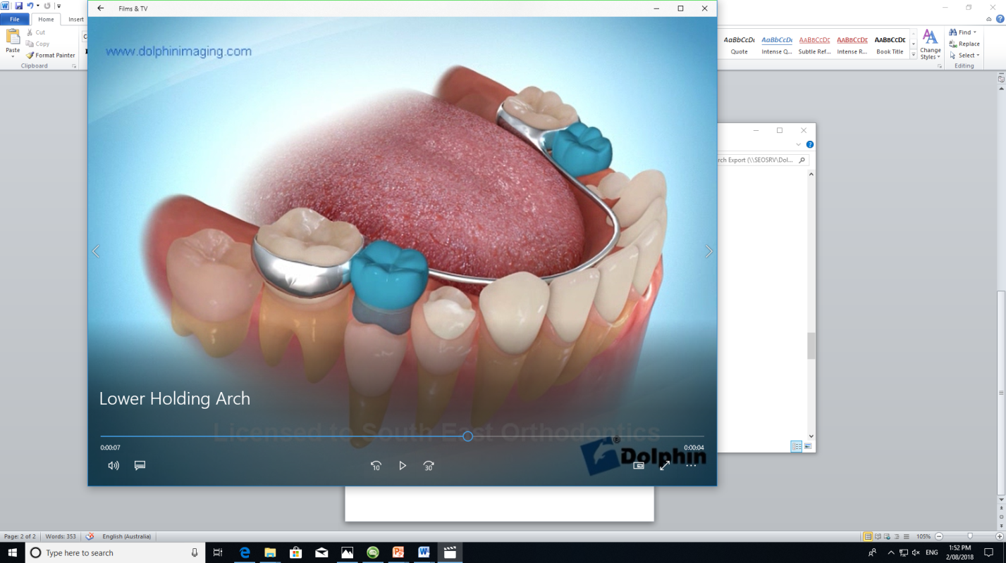

Lingual Arch



Lingual Arch

**Oral Hygiene**

Good oral hygiene is important as there are more areas for food and plaque to become trapped with new appliances in your mouth. Correct brushing is very important to clean the difficult to reach areas, especially along the gum line.

* Brush your teeth 3 times per day
* Use your interdental brush (Christmas tree brush) daily
* Floss as often as possible
* Using disclosing tablets will help you maintain good brushing. Disclosing tablets will stain areas which need further cleaning.

**Diet**

Your diet is important now your appliance has been inserted. To ensure the best possible treatment journey, please follow these recommendations:

* Avoid any hard, sticky and chewy foods. Eg. Lollies, chocolate bars, bubble gum, toffee, hard biscuits, etc.
* Raw fruits and vegetables should be cut into small bite sized pieces. Corn removed from the cob and meat removed from the bone prior to consumption.
* Consumption of any foods or drinks with high sugar or high acidity is to be avoided to ensure the long term health of your teeth Eg. Soft drinks, fruit drinks, energy drinks, etc.

**Wax**

Wax is provided for you to help ease any discomfort your appliance may be causing you. Your appliance may rub against your lips and cheeks causing irritation or ulcers and the wax acts similarly to a band aid. Warm salt water rinses can aid in increasing the healing process. As treatment progresses, the presence of these irritations will reduce.

**Extra Appointments**

Should issues arise throughout treatment and you require an appointment please contact our practice on (03) 9796 2794. It is important to call ahead to schedule an appointment as our peak times are between 3pm and 5pm, and we may not be able to accommodate you at your desired time. For many of these appointments you will be seen by our Dental Therapist. They work alongside our Orthodontists to ensure we can provide more comprehensive care to our patients.